- Spread Operator:
let a = [1, 2, 3];
let b = [4, 5, 6];
let merged = [...a, ...b];
console.log("Merged Array:", merged);

Output:

- Spread
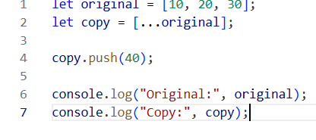
Output:
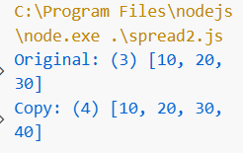

- Spread Merge
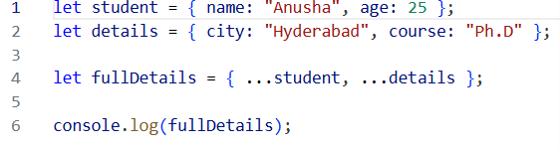

Output:
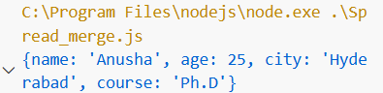

- Spread Operator in function arguments

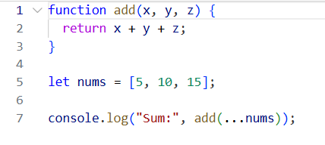
Output:
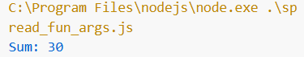

- Rest Operator(…)
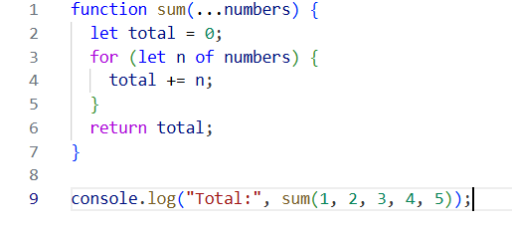
Output:
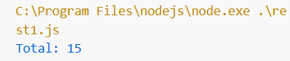

- Rest Operator Example 2
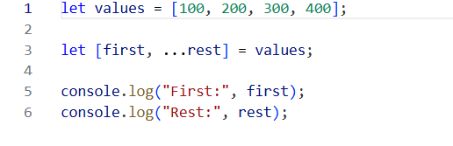
Output:
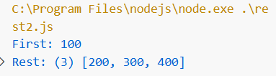

- Destructring Example

// Array destructuring
let numbers = [10, 20, 30, 40];

let [first, second, ...restNumbers] = numbers;

console.log("First:", first); // 10
console.log("Second:", second); // 20
console.log("Rest:", restNumbers); // [30, 40]

// Object destructuring
let student = {
name: "Anusha",
age: 25,
city: "Hyderabad"
};

// Basic + default value + renaming + rest
let {
name: studentName, // renaming
age,
country = "India", // default value
...otherDetails // rest operator
} = student;

console.log("Name:", studentName); // Anusha
console.log("Age:", age); // 25
console.log("Country:", country); // India
console.log("Other Details:", otherDetails); // { city: "Hyderabad" }

// Function with destructuring
function display({ name, age }) {
console.log(`Student: ${name}, Age: ${age}`);
}

display(student);

Output:
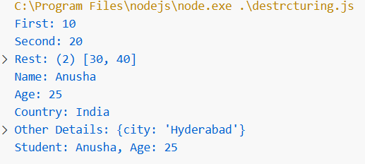

- Arrow Function

// Normal function
function add(a, b) {
return a + b;
}

// Arrow function (short form)
const addArrow = (a, b) => a + b;

console.log("Normal:", add(2, 3)); // 5
console.log("Arrow:", addArrow(2, 3)); // 5

// Arrow function with one parameter
const square = n => n * n;

console.log("Square:", square(4)); // 16

// Arrow function with no parameters
const greet = () => "Hello Students";

console.log(greet());

Output:
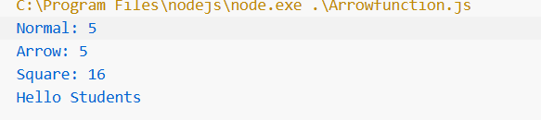

- Template Literals Example

let name = "Anusha";
let marks = 85;

// Using template literals
let message = `Hello ${name}, your marks are ${marks}`;

console.log(message);

// Multi-line string
let text = `This is line 1
This is line 2
This is line 3`;

console.log(text);

// Expression inside template literal
let a = 5, b = 10;
console.log(`Sum of ${a} and ${b} is ${a + b}`);

Output:
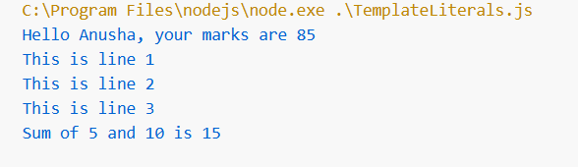

- Optional Chaining
- let user = {
- name: "Anusha",
- profile: {
- age: 25,
- address: {
- city: "Hyderabad"
- }
- },
- hobbies: ["Reading", "Music"],
- greet: function () {
- return "Hello!";
- }
- };

- // Safe object access
- console.log("Name:", user?.name);

- // Safe nested access
- console.log("City:", user?.profile?.address?.city);

- // Missing property (no error)
- console.log("Country:", user?.profile?.address?.country);

- // Safe array access
- console.log("First Hobby:", user?.hobbies?.[0]);

- // Safe function call
- console.log("Greeting:", user?.greet?.());

- // Case when object is null
- let student = null;
- console.log("Student Name:", student?.name); // undefined

Output:
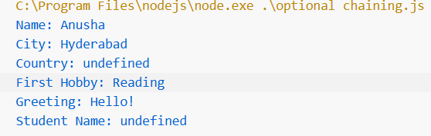

11. Nullish Coalscing
// Different test values
let name = null;
let username = "";
let marks = 0;
let city;

// Using ??
console.log("Name:", name ?? "Guest"); // Guest
console.log("Username:", username ?? "Guest"); // "" (empty string stays)
console.log("Marks:", marks ?? 50); // 0 (valid value)
console.log("City:", city ?? "Hyderabad"); // Hyderabad

console.log("------ Using || ------");

// Using ||
console.log("Name:", name || "Guest"); // Guest
console.log("Username:", username || "Guest"); // Guest ❌
console.log("Marks:", marks || 50); // 50 ❌
console.log("City:", city || "Hyderabad"); // Hyderabad

Output:
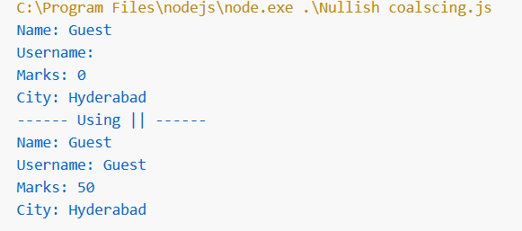

12. Short Circuit Function

// Condition variable
let isLoggedIn = true;
let title = "";

// AND (&&) → runs only if condition is true
isLoggedIn && console.log("Welcome! Dashboard is visible");

// OR (||) → provides fallback value
let pageTitle = title || "Untitled Page";
console.log("Page Title:", pageTitle);

// Anothers example
let marks = 0;

// Using ||
console.log("Marks with || :", marks || 50); // 50 ❌

// Using &&
marks && console.log("Marks are:", marks); // nothing printed

// Changing value
marks = 75;

console.log("Marks with || :", marks || 50); // 75 ✅
marks && console.log("Marks are:", marks); // prints 75

Output:

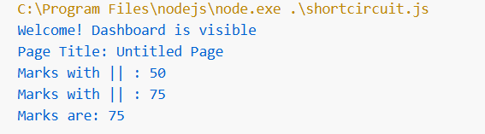

13. Object Shorthand:
let name = "Anusha";
let age = 25;
let city = "Hyderabad";

// Object shorthand
let person = {
name,
age,
city
};

console.log(person);

Output:
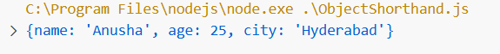
14. Final Program
// Mock fetch function (simulating API call)
const fetch = async (url) => {
console.log("Fetching from:", url);

return {
async json() {
// Simulated API response
return {
name: null, // intentionally null to test ??
email: "anu@example.com",
profile: {
media: [{ url: "avatar.png" }]
}
};
}
};
};

// Arrow function + destructuring + default values
const fetchUserData = async ({ userId, fields = ['name', 'email'] }) => {

// Template literals (dynamic string creation)
const url = `/api/users/${userId}?fields=${fields.join(',')}`;

// Async/await (API call)
const response = await fetch(url);
const data = await response.json();

// Optional chaining (safe access)
const avatar = data?.profile?.media?.[0]?.url;

// Nullish coalescing (only null/undefined replaced)
const displayName = data?.name ?? "Anonymous";

// Spread operator (copy + add new properties)
return { ...data, avatar, displayName };
};

// Function call + destructuring
(async () => {
const { name, email, avatar, displayName } =
await fetchUserData({ userId: "u42" });

console.log("Name:", name); // null
console.log("Display Name:", displayName); // Anonymous
console.log("Email:", email); // anu@example.com
console.log("Avatar:", avatar); // avatar.png
})();

Output:


